**IT DEPARTMENT PROCESS**

**TCS PORTAL LOGIN INTEGRATION**

1. **Form Design**
2. **Work Order Description**
3. **Table Name**
4. **Conditions**

**Work Order Year: 2018-19**

**TYPE:INTERNAL Created By: RAMESH M**

**1. FORM DESIGN**

**1.1 TCS Connect login from TCS Portal Page:**

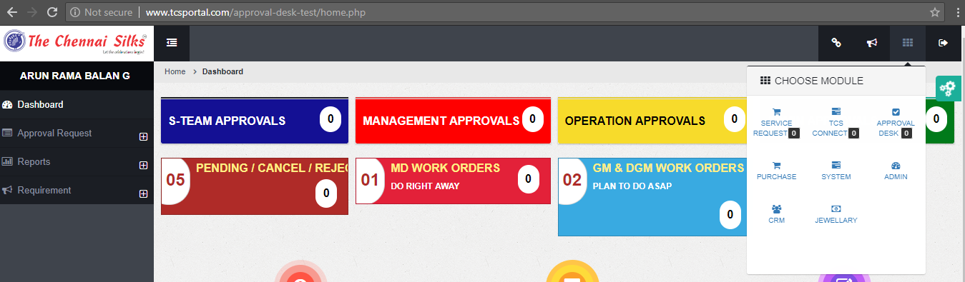

**1.2 TCS Portal login from TCS Connect Page:**

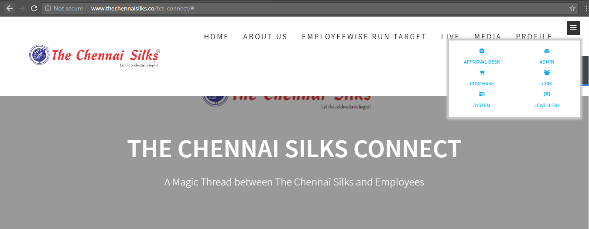

1. **DESCRIPTION**

Login to TCS connect from TCS Portal and Vice Versa

**3. TABLE NAME**

**3.1 Main Table:**

* TCS_USERS
* TCS_USERMETA
* USERID
  1. **Reference Tables:**
* APPROVAL_TOPCORE
* EMPCORE_SECTION
* EMPLOYEE_OFFICE

**4. CONDITIONS**

1.USRCODE = $_REQUEST['uname']

2. user_login = $_GET['userec']